Dataset Information

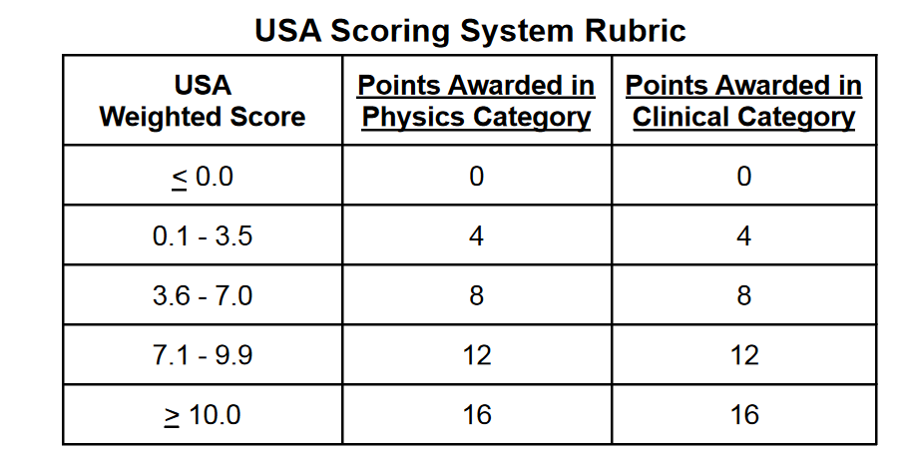

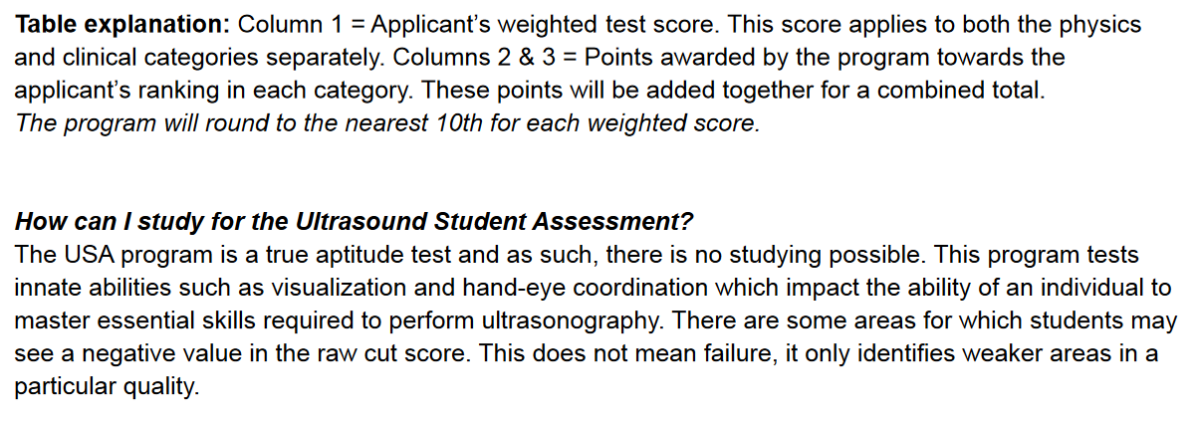

We would like to focus on physics and clinical to determine success in the program.

Program focuses on the items: Preapplication the critical thinking, persistence

Persistence: answer the question several times to get it right. You stick to something even when its hard.